I’m Vicky Nicolson-James, and I’m really excited to have been nominated as a new trustee at ECHO. I got to really know the Radio EECHO team last year when I had the pleasure of talking with them about the community company I run, and we had such a great time that I decided it would be wonderful to get more involved.

Family is a huge part of my life. I live just outside Leominster with my husband Andrew (Clemmy’s dad) and our three daughters. My eldest Lucy is 27, Clemmy is 22, and Pippi is 14 and still at school. Some of you may already know Clementine — she went to Westfield School, sixth form, and Star College, and she’s now enjoying ECHO activities too. I often accompany her on Wednesdays to About Face Youth Theatre at the Courtyard, which honestly is the highlight of my week.

We’re also a family of dog-lovers — we have Alfie, a Sealyham Terrier, and Otto, a Large Munsterlander. They’re best friends and keep us busy with long walks. Outside of family life, I love playing tennis, walking, and listening to music. My guilty pleasure is dancing to 80s tunes, usually just to make my kids laugh!

Alongside my new trustee role, I also work as a therapist specialising in emotional support and hypnotherapy — something I’m deeply passionate about.

I’m also the Director and co-founder of Accessible Herefordshire CIC, a community company I set up with my friend Angela. We created Accessible Herefordshire because we’re passionate about making this county a place where everyone feels welcome — whether you’re a resident, a visitor, or a local business. Our aim is simple: to build an inclusive, supportive environment in Herefordshire where everyone feels valued and appreciated.

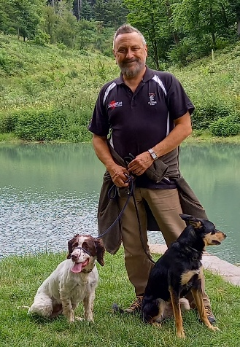Hello everyone.

To introduce myself I'm known as KP - a nickname that has stuck since I was at school because they are my initials and I usually had a bag of KP nuts in my lunch.

I'm now semi retired after a career in business as a project manager and run a rare breed smallholding in North Herefordshire with sheep, goats, poultry , dogs and cats. Two of my dogs, Teazle and Nelly are in the picture with me on a walk on at Bircher Common.

I have been volunteering at Eaton Barn for a while and also work at the Houghton Project in Bodenham. It's all about the participants for me and I love working with them and listening to their stories.

I'm also interested in archaeology, conservation, sport and Real ale.

It's great finding out all about being a trustee and getting to know the fantastic projects that I'm less familiar with. I look forward to supporting ECHO in the future.

Best KP