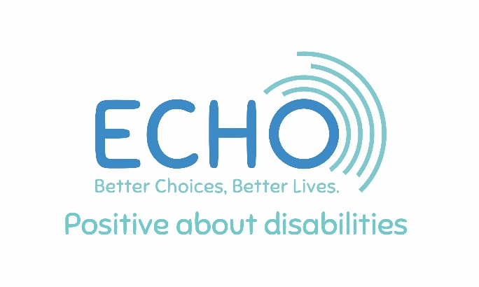
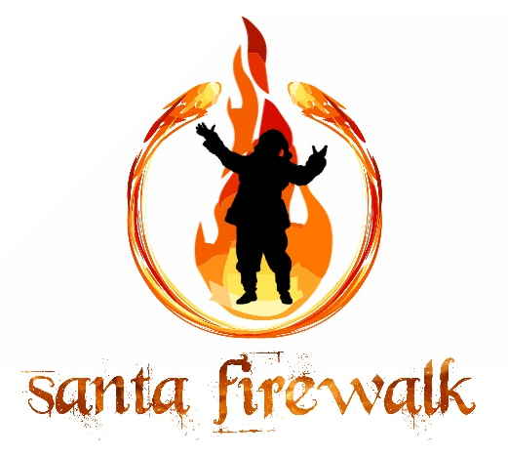

ECHO Fire Walk Sponsorship Invitation
Event: ECHO Evening Fire Walk
Date: Thursday 27 November
Venue: The Shell Store, Rotherwas Munitions Factory, Canary Drive, Skylon Park, Hereford HR2 6SR
ECHO is excited to host a spectacular evening Fire Walk and we invite you to join us as a sponsor for this unique fundraising event.
Sponsorship Opportunities
- Headline Sponsorship – £500
or two sponsors at £250 each
- Prominent logo placement on all event materials, social media promotions, and on-the-night signage
- Two complimentary tickets
- Supporting Sponsorship – £150
  - One complimentary ticket
  - Your business promoted to 1,700+ local followers on our social channels, featured in the press, and highlighted in event publicity
As a sponsor, we’ll work closely with you to ensure you gain maximum visibility and benefit from your support.
About ECHO
ECHO is a much-loved Herefordshire charity providing day care and meaningful activities for over 150 individuals with learning and other disabilities. Through 30 different projects, we help people build confidence, develop skills, and enjoy better life choices.
The Fire Walk Experience
Walking barefoot across a path of glowing embers is a thrilling, life-affirming challenge, not a trick or illusion, but a real achievement. Participants step off the fire with a sense of extraordinary accomplishment.

We are partnering with Blaze – The Firewalking Experts, pioneers of the UK’s first fundraising fire walk in 1984. With thousands of events delivered across the UK and internationally, Blaze provides expert pre-walk training and ensures a safe, empowering experience trusted by global organisations.
Evening Programme
- 4:00 – 7:00 pm – Craft Fair at The Shell Store
- 5:00 – 5:45 pm – Fire Walk Registration (£25 per ticket; advance purchase encouraged)
- 5:45 – 6:45 pm – On-site Fire Walk training. During this time, ECHO’s theatre company, About Face, will perform their original play The Canary Girls in the foyer.
- 6:45 – 7:30 pm – Fire Walk in the car park
The Canary Girls celebrates the vital role of the Rotherwas Munitions Factory in WWII, where two-thirds of the workforce were women filling shells for the war effort.
How Funds Are Raised
All proceeds, including ticket sales and sponsorship, directly support ECHO’s ongoing work. Participants are also encouraged to raise additional sponsorship to further our impact.
Why Sponsor
This event offers your company a powerful opportunity to:
- Inspire your team with a fun, challenging, and team-building experience
- Strengthen your corporate social responsibility profile
- Gain exposure to hundreds of attendees and thousands more through media coverage and our active social channels
Interested in Sponsoring?
Please contact:
Penny Weir, Fundraising Officer
penny.weir@echoherefordshire.co.uk | 07796 240325
ECHO Herefordshire, 40 West Street, Leominster HR6 8ES
Tel: 01568 620307 | Charity Number: 1096449

