The StEP’s Volunteering Staff Team
The StEP is overseen by Roz Johnson, our Volunteer Manager who is highly experienced
in working with our participants and volunteers.
Roz was born in Birmingham and moved to the
Black Country in 1997, until relocating to Herefordshire in 2015 with her daughters.
Roz started working in the education sector in 2002 and has been a Higher Level Teaching Assistant and an Assistant SENCo in primary schools until she joined ECHO as a Volunteer Coordinator in August 2021. She has a BSc (Hons) degree in Child and Adolescent Mental Health, and a master’s degree in Psychology. Roz is passionate about the work she does with ECHO and is enjoying the challenges being a manager brings.
You can contact Roz on: 07719 023534 or (01568) 620307
Or email: roz.johnson@echoherefordshire.co.uk
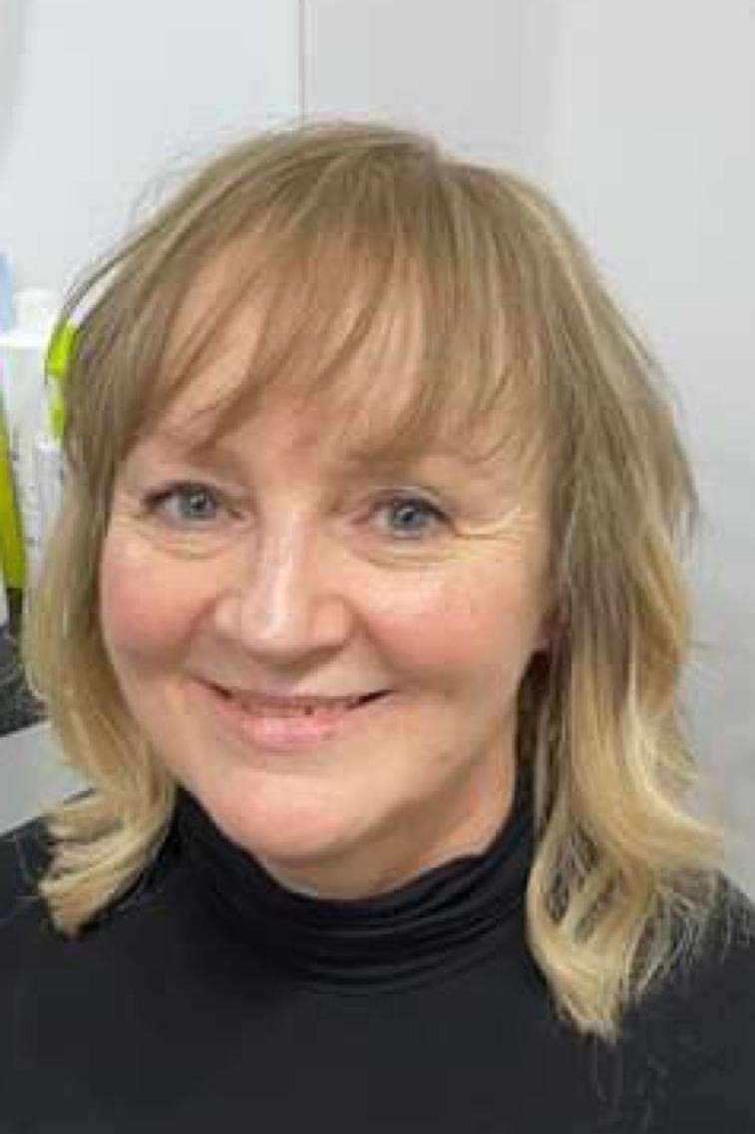
In April 2024 Michelle Hodnett joined the staff team as an Outreach Officer with the Steps to Employment Project. Michelle is responsible for recruiting, training and supporting StEP beneficiaries with disabilities and other support needs into work experience, volunteering opportunities and paid employment in the community.
She has previously worked in the Health and Care sector for 35 years in various roles. This has included working in Occupational Therapy, Social Work and hands on caring.
Michelle is married to Keith and has 2 daughters and one granddaughter.
She has two fluffy Cavachon dogs, called Ella and Heidi, and enjoys walking, cooking, horse riding and meditation.
You can contact Michelle regarding the StEP at:
michelle.hodnett@echoherefordshire.co.uk or on 07389024730
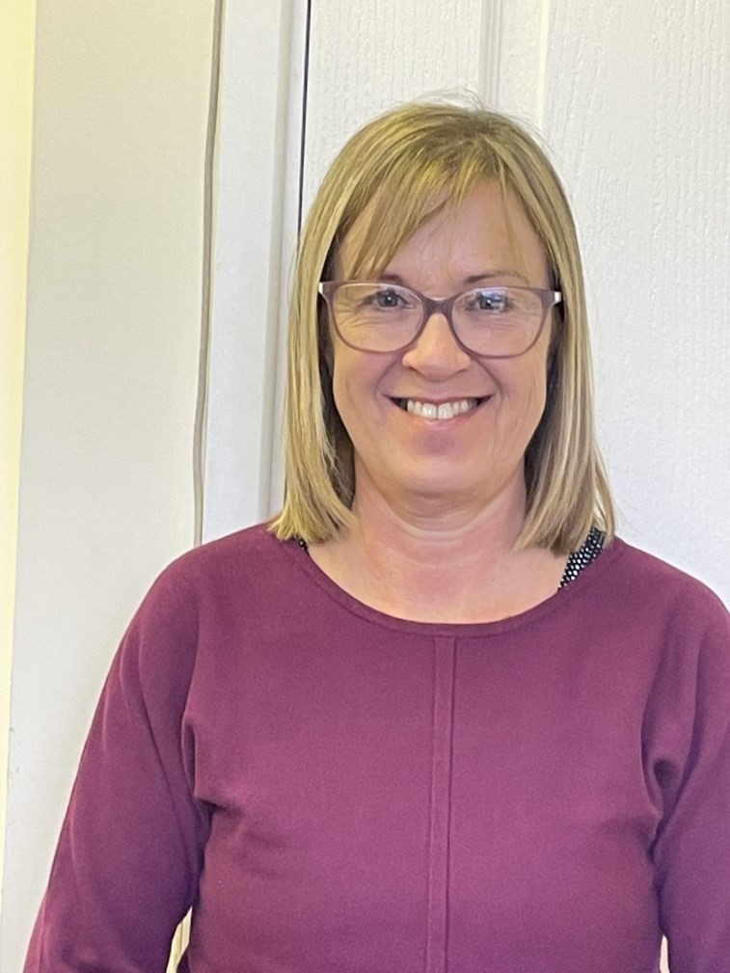
Sue Palliser is the Volunteer Coordinator within the StEP staff team. Sue is responsible for the active recruitment of volunteers to be placed within ECHO projects. She trains and inducts new volunteers, and works with Roz to support all ECHO volunteers.
Sue started her career at ECHO as a volunteer at Eaton Barn. After 2 months, she was employed there as a support worker and has recently joined the StEP team in January 2024. Previously, Sue has worked mainly in childcare, based in nursery environments.
Sue’s husband Mark is an ECHO volunteer and has spent time running workshops from the green woodworking area at Eaton barn. She was born in Birmingham and moved to Herefordshire in 1994. She has 3 children and 4 grandchildren. Sue enjoys cycling and sewing. You can contact Sue on 07389024712 or email her at:
sue.palliser@echoherefordshire.co.uk

