Volunteer Voice Newsletter

March 2024

Welcome to the March edition of the Volunteer Voice newsletter! Finally it feels like spring is on it’s way… the daffodils are blooming, lambs are in the field and if it stops raining/ snowing/ being foggy and the sun comes out, it may actually feel like spring is here.
Read on for information about joining our Tuesday Yoga Group, introductions of new volunteers, current ECHO volunteer figures, recipes to put a spring in your step, an invitation to visit one of the StEP’s new partner companies, details of a volunteer vacancy for Radio ECHO and more!
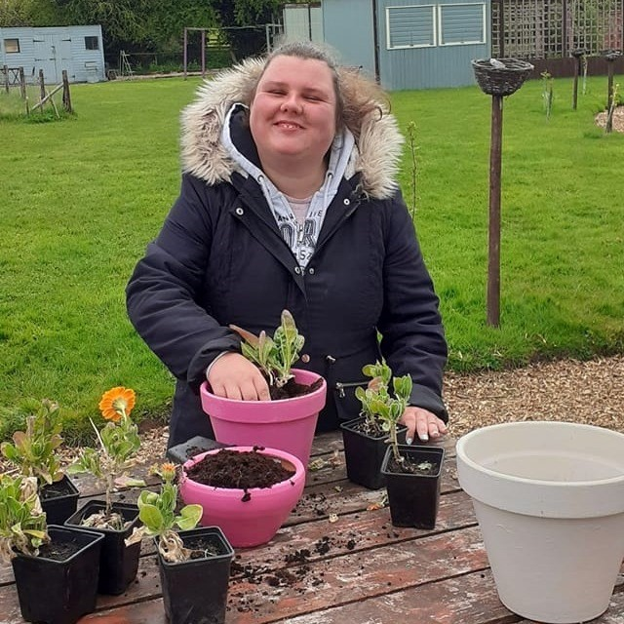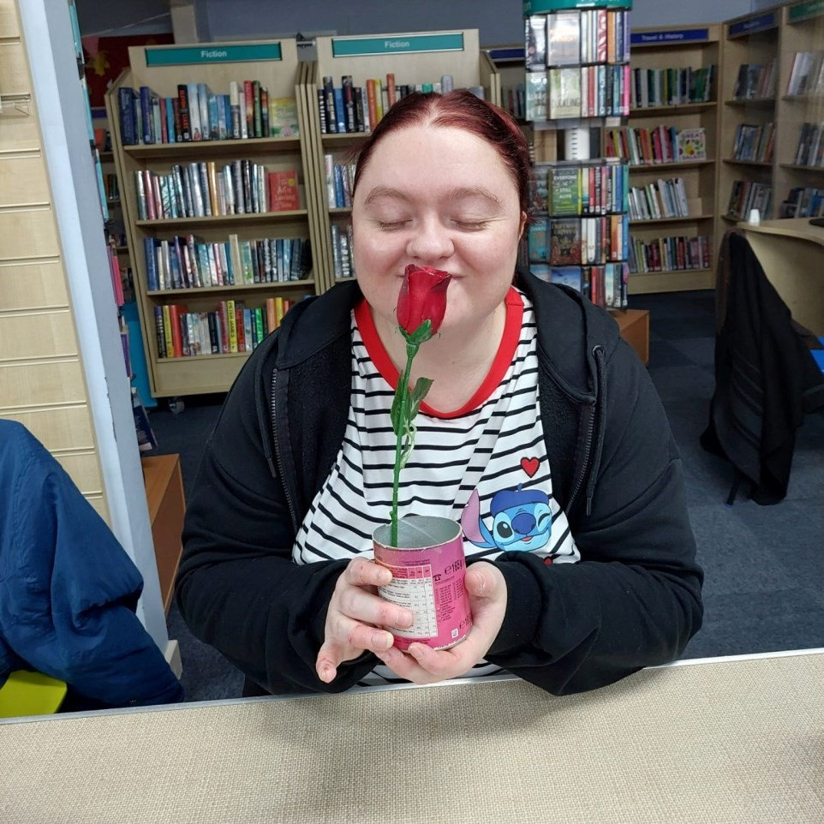

^{Fiona potting up at Eaton} Laura enjoying the scent of
^{Barn} spring at Wednesday
LifeLinks

Yoga Group
Jane Stockton has been an ECHO yoga tutor for many years. She runs the Yoga Group every Tuesday at Leominster Library from 3:15—4:15pm, which is attended by a few of our participants. Jane is looking to enlarge the group and is extending an invitation to anyone who would like to start yoga.

Jane said “the yoga sessions are designed to be accessible to all, and includes movements to keep all the joints in the body supple along with standing and seated postures to encourage movement and stability, the class ends with stillness and quiet relaxation. The approach is informal, often humorous and uses imagination, with time if needed for everyone to share news and thoughts.”

If you would like to join the group, whether you choose standing, seated or wheelchair accessible yoga, please contact the ECHO office on (01568) 620 307. The cost is £7 per session, or you can prebook 6 sessions for £35. Mats are available or you can bring your own.
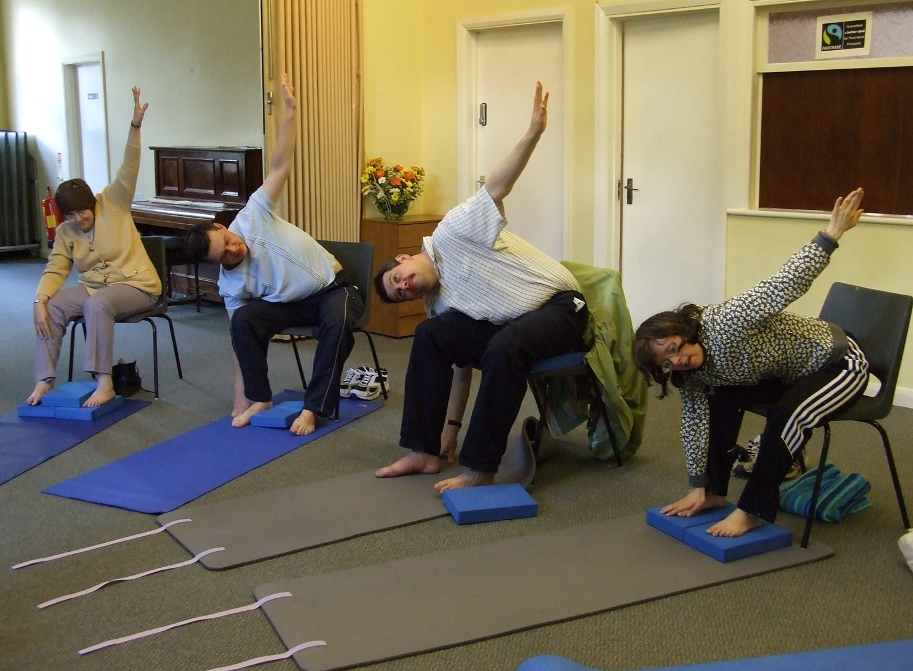

Welcome to StEP Beneficiaries
We welcome new beneficiaries Tanis Nash, Michael Noble, Gwynnan Smith,
David Riley, Jeanette Reid, Tim Spivey and Rachel Exelby to the Steps to Employment Project. They are following Route 1, which is the steps into employment.
Chloe Powell has joined Friday LifeLinks, Jenny Bartlett is now volunteering at Vicarage Street Garden and Naomi Harris has recently started at Studio Mirai.
These have followed route 2 of the StEP, and become ECHO Project volunteers.
Welcome all!
For more information on the routes of the StEP, please visit the ECHO website and click on the Volunteer page. You can also follow the link on there to find out about the StEP staff team and refresh your volunteer training by following the link to the Volunteer Training Pack.
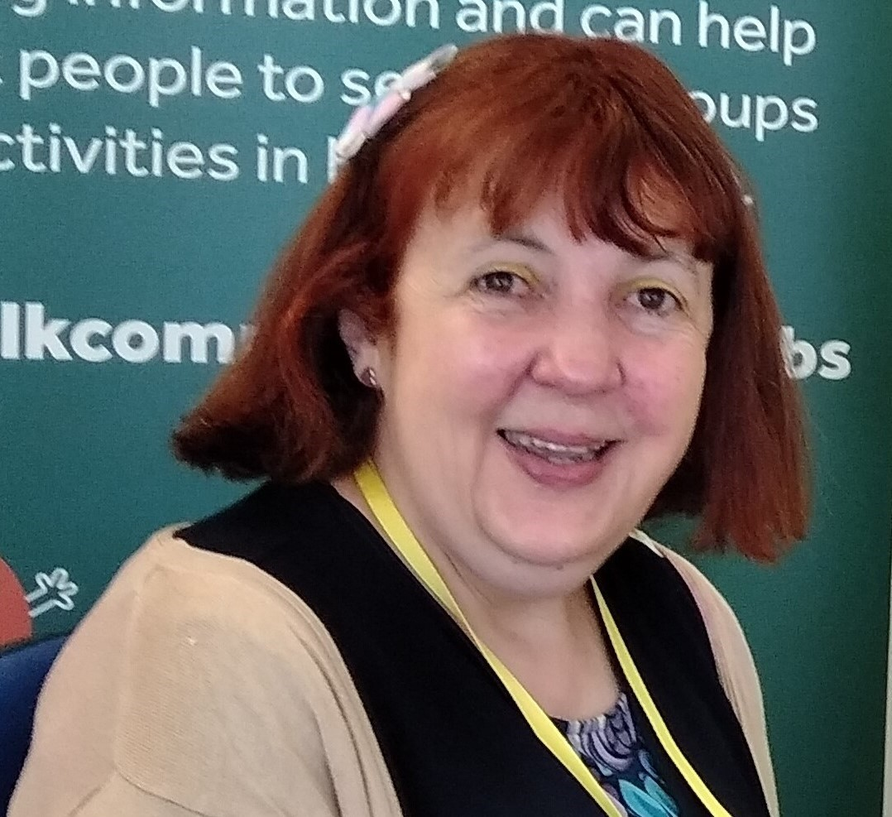
ECHO Participant Jeanette Reid has been offered a volunteer placement at the Creative Café in Leominster on a Tuesday afternoon.

Volunteers’ Week
Volunteers' Week is an annual celebration of the contribution millions of people make across the UK through volunteering in their communities.
As highly valued volunteers, the StEP team would like to celebrate YOU during the week of the 3rd to the 9th June.
Let Roz or Sue know of any ideas you have about how you would like to be celebrated. Would you like another Social Learning Day (training and lunch), or a social only get together? This is about you, so the StEP team would like you to be involved in the planning of the celebration.
The figures below show how unbelievably valuable volunteers are to ECHO:
228 volunteers have the status interested, active or on hold.
167 volunteers have the status interested or active.
149 volunteers have the status of active. This includes 105 regular (once a week at least) and 44 ad hoc volunteers.
Based on the volunteers who attend regularly, this amounts to:
630 volunteering hours per week.
32,760 hours per year.
That is the equivalent of 16.8 full time staff!
So, you can see why a celebration of our volunteers is so important .

Spring Celebration Salad
Prep:20 mins Cook:30 mins Serves:2

Celebrate spring with this salad using the season’s most exciting food, including new potatoes, asparagus and peas.
- 300g new potatoes, scrubbed clean but not peeled, big ones cut in half

- 1 mint sprig
- 2 eggs
- 200g asparagus,
- 50g fresh peas, podded
- 4 tbsp mayonnaise
- 1 green apple, cored and finely chopped
- 3 spring onions, finely sliced
- 1 tsp capers, drained
- 2 tbsp olive oil
- 1 tbsp white wine vinegar
- 1 Little Gem lettuce, leaves washed and dried, heart split in two

Method
Heat oven to 200C/180C fan/gas 6. Drizzle the bread with some olive oil and season, then roast in the oven, turning halfway through, for 12-15 mins or until crisp and golden. Once baked, rub with the raw garlic and break or cut into croutons.
Bring a pan of water to boil. Add the potatoes, mint and 1 tsp salt and simmer for 15 mins until the potatoes are tender. Don’t be afraid of overcooking them – they’re far better tender than chalky. Drain the potatoes and discard the mint sprig.
Meanwhile, bring another pan of water to the boil and lower the eggs into the water. Bring back to the boil and cook for 6 mins. Drain, then run the eggs under cold water to cool. Tap the eggs on the work surface and peel.
Bring another pan of salted water to the boil. Chop the asparagus spears into three and boil in the water for 3-4 mins until just tender. Scoop out with a slotted spoon and refresh in cold water. Bring the water back to the boil and add a pinch of sugar. Add the peas to the water and cook until tender (about 2-3 mins). Drain.
Toss the potatoes with 2 tbsp mayo and the apple, spring onions and capers. Whisk the olive oil and white wine vinegar together, season, then dress the lettuce along with the asparagus and peas. Spread the remaining mayo across your plate, top with the potatoes and dressed salad, halve the eggs and add more mayo, if you like. Garnish with the croutons.

Chicken, Bacon and Leek Traybake

This chicken, leek and bacon bake is a throw-it-all-together-and-bung-it-in-the-oven kind of dish. The ideal midweek meal.
Serves: 2
Prep time: 10 minutes
Cooking time: 30-45 minutes

Ingredients

- 300g charlotte potatoes, or any waxy potatoes, thinly sliced

- 25g butter, plus extra for greasing

- 100g smoked lardons

- 2 garlic cloves, crushed

- 1 leek, sliced

- 5 fresh thyme sprigs, leaves picked, plus extra for sprinkling

- 130g pack ready-cooked chicken slices

- 100ml chicken stock, hot

- 100g ready-grated cheese such as Gruyère or
Cheddar
Method:

Preheat the oven to 200°C/fan180°C/gas 6.

Put the sliced potatoes in a pan of boiling salted water and simmer for 3 minutes. Drain, then set aside to cool.

Meanwhile, melt half the butter in a frying pan over a gentle heat, add the lardons and cook until beginning to crisp.

Stir in the rest of the butter, the garlic, leek and thyme, and sauté gently over a low heat for 10 minutes.

Butter 2 shallow 300ml baking dishes, then add a layer each of potatoes, leek mix and chicken slices, seasoning as you go and finishing with a layer of potatoes.

Pour over the hot stock, scatter over the cheese, then sprinkle with extra thyme.

Bake for 20-25 minutes until bubbling and cooked through – cover with foil if the top begins to brown too much.

No Bake Lemon Cheesecake
Serves: 6

Prep: 20 mins

Cook:5 mins plus chilling

Ingredients

110
g

digestive biscuits

50
g

butter

25
g

light brown soft sugar

350
g

mascarpone

g
75

caster sugar

1

lemon,

zested

2
-
3

lemons,

juiced (about 90ml)

Method
Crush the digestive biscuits in a food bag with a rolling pin or in the food processor.
Melt the butter in a saucepan, take off heat and stir in the brown sugar and biscuit crumbs.
Line the base of a 20cm loose bottomed cake tin with baking parchment.
Press the biscuit into the bottom of the tin and chill in the fridge while making the topping.
Beat together the mascarpone, caster sugar, lemon zest and juice, until smooth and creamy.
Spread over the base and chill for a couple of hours.

Yarpole Gallery Café
However, if you are not in the mood for cooking, why not visit one of the StEP’s new partner organisations for coffee, cake or lunch. The StEP is hoping to place a StEP beneficiary in the Gallery Café for a work experience placement. If you know anyone who you think would benefit from this opportunity and is looking to overcome barriers to employment due to disability, please let the StEP team know.
The Gallery is located on the mezzanine level above the shop in St Leonards Church, Yarpole. The Café was established to provide a gathering place for the village and visitors. It is a place where people can enjoy home cooked food and cakes in a beautiful setting. It helps in keeping the church building maintained and has a group of fantastic volunteers.
Enjoy food and drinks in the stunning church or outside when the sun is shining and have a wander around the village shop, located in the ground floor of the church.
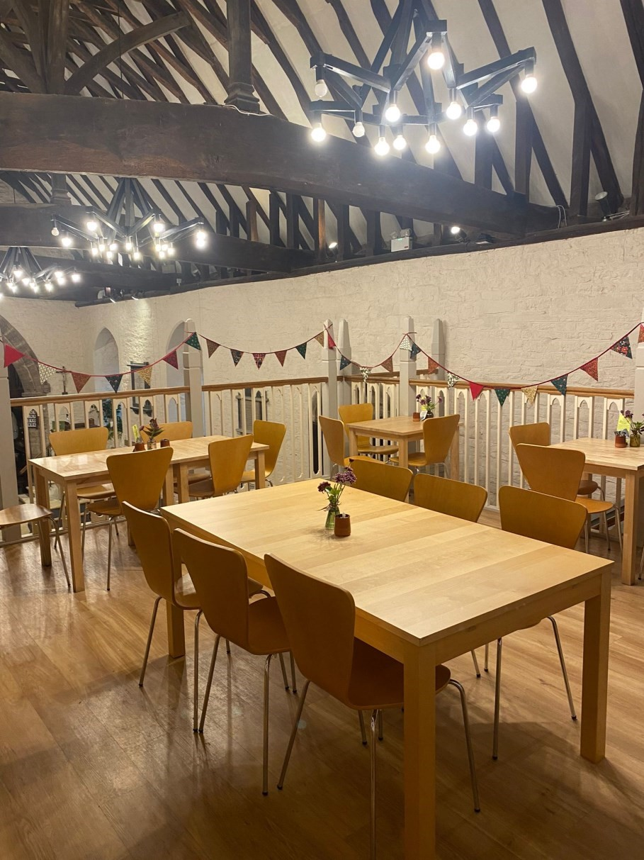
Why not visit for hot chocolate, coffees or teas, with delicious home-made cakes and fragrant cheese scones?
Light lunches on Thursdays and Fridays include soups, quiches, paninis and baked potatoes.
Opening times:
Monday, Tuesday, Wednesday 10.30 - 12:30 for drinks, homemade cakes & scones.
Thursday and Friday, 10.30 - 15:30 with light lunch to eat in or takeaway, between 12.00 and 2.00pm.
Saturday Brunch 10.30 - 12.30 delicious bacon rolls, croissants and the famous ‘revved up’ cheese scones.
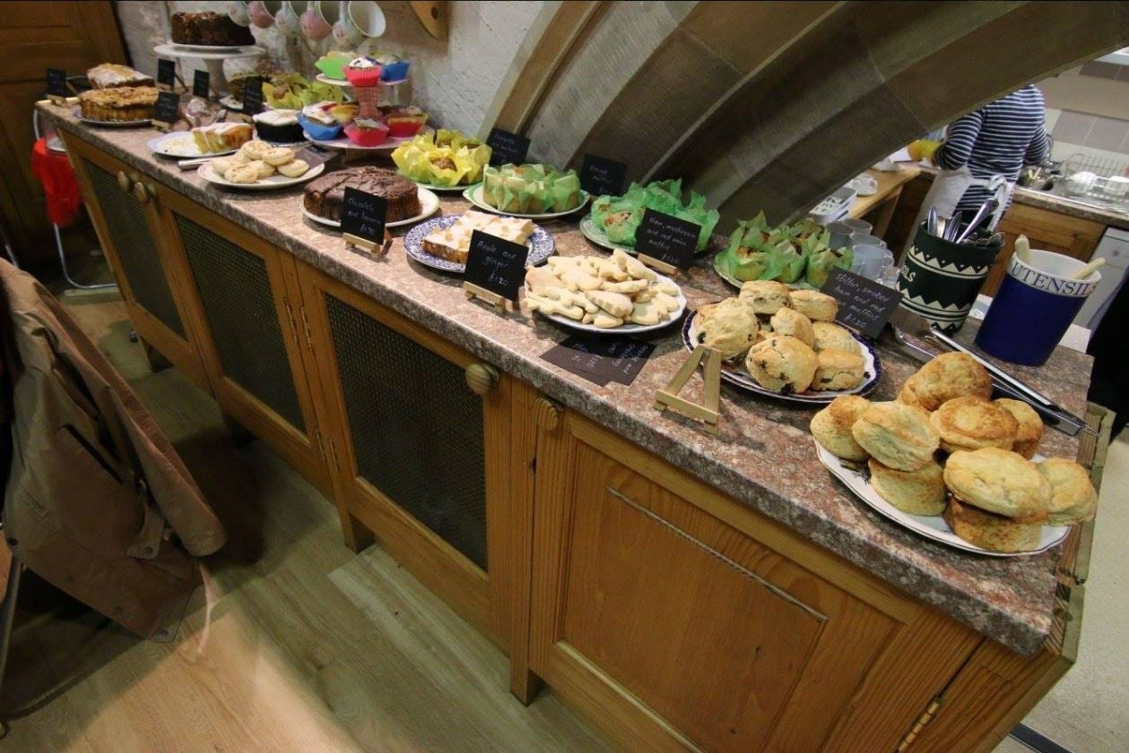
Volunteer Needed at Radio ECHO!!!
Radio ECHO is seeking a Volunteer Support Assistant for its new project day, which began on Friday March 1st. Radio ECHO engages participants to learn all the skills needed to take them from production meeting ideas through live stream broadcasting in one session.
Whilst the quality of the broadcast element of the sessions is central to the session, the planning,
researching and learning aspects of the day are equally important, if not more so, and the Volunteer Support Assistant will play a crucial part in helping the participants achieve in these areas.
Duties to include:
Supporting the Project Lead in delivering Radio ECHO sessions.
Supporting individuals or groups of participants to get the most out of their learning/ the session as a whole.
Helping participants who need extra support to complete tasks, which may include:
- Searching the internet for news stories/features
- Copying, pasting items to Word/text documents
- Helping to organise ideas and edit written features to correct word length
- Assisting the use of other software and equipment needed for a broadcast
- Leading/help leading the session if Project Lead not available – e.g., holiday cover
The Volunteer Support Assistant will not be responsible for planning and preparing sessions.
Useful Skills & Experience
- Good reading, writing and verbal skills.
- Good IT skills.
- Well organised and reliable.
- Experience of working with people with learning disabilities/additional needs desirable but not essential.
- Confident and creative in interacting with people with additional needs and being sensitive to those needs.
- Commitment to equal opportunities.
- Available Fridays essential, potentially to help cover Tuesday session desirable.
Training and support provided
- Induction/training with Volunteer Manager.
- Ongoing training and support provided by the Radio ECHO Project Lead.
- Aims/objectives/principles involved in the Radio ECHO session.
- Use of broadcast equipment/software etc.
- How to set up/pack down equipment needed for the session.
- Principles of audio recording/editing (optional).

ECHO Darts Match
All volunteers, staff and participants are invited to take on the ECHO darts team in a match on Thursday 14th March.
This is being held at Shooter’s Bar in Leominster at 5pm. Let Letty know if you would like to enter and play, or just come along and watch!
Don’t forget to spread the word about ECHO’s 2024 colour fest!

Eaton Barn fundraising Initiative

Eaton Barn are launching their new fundraising initiative and are looking for new members now. Full details are on ECHO’s Facebook and you can join by returning a registration form via email and BACS payment if getting to Eaton Barn or the ECHO office isn't possible for you.

