Trustee Nominations

Every year at the AGM we look to see who is on our Board of Trustees. If someone new wants to join, they stand for election and we take a vote.
Here are the people who would like to become an ECHO Trustee. The good news is that there is room for all of them to join if the ECHO members want to vote them in.

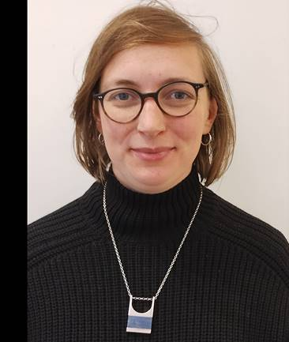
Becca Antink
I grew up in Herefordshire and live in Leominster, having recently moved back from London to be closer to family and our beautiful countryside.

For my day job I work to get affordable and social housing built for the Mayor of London.
I have a masters in Social Policy from the London School of Economics and previously worked as a researcher at the Royal Society of Arts and the Institute for Public Policy Research, and on a number of projects for Herefordshire Council.
I was previously a trustee of RUSS, a community land trust in Lewisham and have volunteered on self-build projects and organic farms in the UK and Canada. I’m an avid gardener and have volunteered on a number of community and guerilla gardening projects - one was even on the site of an abandoned nuclear bunker! I’m also a keen cook and catered a traditional Ukrainian charity dinner to raise money for humanitarian aid and psychological support for people displaced by the war in Ukraine.
In my spare time, I love crafts and getting out into nature for camping, walks and foraging. All ideally followed by a swift half in The Grapes and big cook up at home with family, friends and the dog.

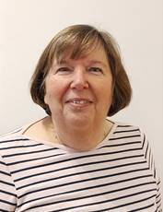
Judith Haines
I moved to Leominster more than 35 years ago and until a few months ago was a partner in a local firm of solicitors specialising in property work.

When my son Nick was younger I was a governor of what was then Leominster Junior school for some years.

Nick is now 32 years of age and an ECHO participant. He attends About Face and Radio ECHO, both of which he loves, as well as many of the social and leisure activities. Having seen the great work that ECHO does first hand I was keen to become involved. The opportunity to do this came in April of this year when I retired and shortly after I saw that Radio ECHO was looking for a volunteer. Having got Nick’s permission I contacted ECHO to say that I was interested and I have now been volunteering every week for more than 6 months. I must say that I love my Tuesdays! I have been amazed by the knowledge and hard work of the participants but we also have a lot of fun along the way!

Once I started volunteering I became aware that ECHO were looking for new trustees and I decided to put myself forward in the hopes that my skills and experience would be of some use.

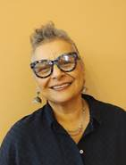
Hanna Woodall
I've lived in Leominster for 7 years now and feel very much part of the community.
I'm married with 5 grownup children and find being a mother very rewarding.
My professional life has been varied and fulfilling. In my early adulthood I was a secondary school English and Drama teacher before moving into 6th form and adult education.
Then when I hit 40 I felt called to the Anglican church as a minister. My church life involved being a vicar in rural parishes, several years in hospice chaplaincy before finishing up in a very deprived inner city parish in Coventry. Much of my experience there involved working with the homeless and people living with addiction.
After retiring from church life I moved to Leominster and began work in a residential home for people with learning disabilities; that's when I came across ECHO. As I accompanied participants to many ECHO projects I learnt more about the charity and found the projects and people inspiring.
Just at the end of lockdown, 2 friends and I set up a vegan community cafe in Leominster. We were all volunteers and in the span of 2 years managed to donate about 5k to community projects. It was fun but hard work. After closing the cafe I had more time to do voluntary work and the natural choice was to join ECHO. I'm a Wednesday volunteer at Studio Mirai which I love as well as working in our local hospice shop. I'm involved with our local Ukrainian community too. Cooking and baking, making weird things like kimchi and keffir is a favourite hobby. Gardening brings me much joy and I've just brought home a 9 month old rescue cockerpoo.
I am really excited to be joining ECHO as a trustee. The participants, staff, volunteers and projects are fantastic. What an honour to be joining such a great team.

I am really excited to be joining ECHO as a trustee. The participants, staff, volunteers and projects are fantastic. What an honour to be joining such a great team.

Clare Cathcart
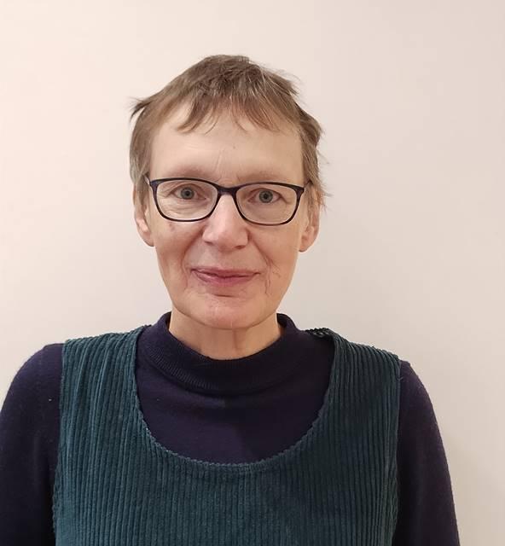
I am excited to be nominated to be a new trustee at ECHO.
Having lived and worked, as a GP, in Leominster since 1994 I have been drawn to the visible work that ECHO does in the town. I said that when I retired I would like to volunteer with them and so I have been volunteering at the Priory Centre for the last six months.

Since starting to look at the trustee role I have learnt a lot more about the less visible activities that ECHO is involved with and am even more committed to supporting the organisation.
In addition to my involvement with ECHO, I volunteer at the foodbank as a Money Mentor, helping clients solve their financial issues. I am also active at the Priory Church where I am Church Warden. I have three kittens, nearly cats, who do not choose to join me on my weekly walks with Leominster Rambling Club.

