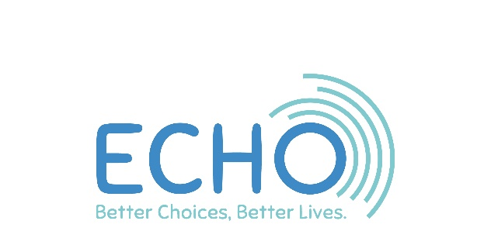

ECHO FOR EXTRA CHOICES IN HEREFORDSHIRE
SUPPORT WORKER – Wednesday Lifelinks, Hereford
JOB DESCRIPTION

ECHO is a charity mainly working with people with moderate or severe learning difficulties. We also support people with mental health needs or who have physical or sensory impairments. ECHO runs 28 different activities each week in community settings across Herefordshire. We are based at 40 West Street, Leominster where we have a shop with offices above.

ECHO is committed to providing services that promote choice, rights and independence for disabled people in Herefordshire. We make sure that we involve and inform disabled people about the services we provide.

Main Tasks
Under the direction of the project manager, to support the running of ECHO day services as quality placements for people with learning and other disabilities by:
- Providing practical support to our participants to ensure they are:
- Welcomed and feel safe
- Made to feel valued and encouraged to contribute
- Supported to develop new skills and try new activities to build confidence
- Supported to achieve their personal outcomes and goals
- Given any assistance needed to ensure they are comfortable and maintain their dignity at all times. This may include physical care, assistance or prompting in accordance with the individual’s care plan, assistance to take medication or manage their continence.

- Planning and supporting daily sessions to ensure that a range of valued activities are provided for the participants.

- Helping our participants to be included in and contribute to their local community, make friends and take part in local activities and events.

- Giving clear guidance and support to any project volunteers on their role and the tasks to be undertaken.

- Working within ECHO’s Health & Safety policies and Risk Assessments.

- Taking appropriate and immediate action to ensure our participants are safeguarded from abuse and to report any instances of alleged abuse which you witness or become aware of.

- Keeping good records, communicating effectively and sharing information as appropriate whilst maintaining confidentiality and data protection requirements in line with ECHO policies.

- Logging all monies accurately and in accordance with agreed procedures.

- Keeping the workplace clean, tidy, and free from hazards.

- Attending relevant training events and activities; staff meetings and the AGM.

- Working within the Equality & Diversity statement of ECHO.

- Work with the participant representative group and trustees to ensure those who use our services are listened to and engaged
- Undertaking any other duties commensurate with the post, as requested by the Chief Officer or your line manager.

Additional Information
The postholder will work at Wednesday Lifelinks Project, Hereford. All staff are required to undertake six weekly supervision sessions. This post is subject to an enhanced DBS check.

This is a part time appointment of 7.5 hours per week to be worked on a Wednesday 8.45am to 4.15pm.

How To Apply
Please complete the enclosed application form, ensuring that your answers address the requirements of the job description and person specification. Do not send a CV. Only the completed application form will be considered.

The closing date is Monday 14th February 2022 by 5.00pm.
Please return your application to:
The Office Manager, 40 West Street, Leominster HR6 8ES

Interviews will be held at the end of February at The Belmont Community Centre, Hereford. Shortlisted candidates will be contacted by 18th February. If you have not heard by then you should assume you have been unsuccessful.

SUPPORT WORKER

PERSON SPECIFICATION

 | ESSENTIAL | DESIRABLE
Experience | Experience of working with disabled people or those with extra support needs.
Qualifications  And Training | A good general level of education | Training in:  Health & Safety  Food hygiene  First Aid  Moving & Handling  Safeguarding
Skills And Abilities | Good communication skills.  Able to use own initiative  The ability to work well within a team.  An ability to relate to a wide range of people from different backgrounds  Able to understand and follow instructions & policies | Able to communicate using Makaton signing
Personal qualities and Other Factors | An understanding of the importance of confidentiality.  A commitment to social inclusion and developing valued roles for people with a disability  Have an openminded attitude to life, believing that everyone has gifts and capacities  Self-motivation, enthusiasm, sensitivity and diplomacy.  Willingness to accept advice and supervision and act accordingly | Car driver with access to a reliable vehicle for work

