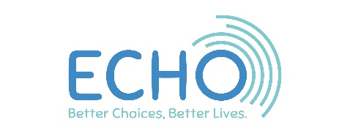
Voting Paper for the ECHO AGM
10th December 2021
Each year at the AGM ECHO members need to vote for the people who have volunteered to become trustees and run our charity. Every year 3 Trustees must stand down and Sue Nash, Mand Hamblin and Joy House have all stopped being trustees.
This year 4 people are standing for election. We have interviewed them and checked that they can be trustees. If you want them to become an ECHO Trustee, put a tick next to their name. There are enough places for all 4 to join us as Trustees.
Name | Information | Do you want them to be a Trustee?  Yes or No
Joy House | Joy has been an ECHO Trustee for 5 years and was co-chair for 2 years. She volunteers at Clever Betsy and would like to stay on as a Trustee
Mand Hamblin  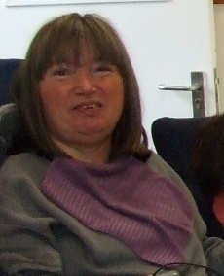 | Mand has been an ECHO Trustee for 5 years and has been vice chair of the board for 3 years. She loves being a Trustee and wants to keep being one.
Name | Information | Do you want them to be a Trustee?  Yes or No
Matt Jones | Matt is an About Face Actor and was on Rep Group for 6 years. He has been an advisor to the Board and will make an excellent Trustee
John Bradford | John has been attending meetings and learning about ECHO. He has a lot of Finance and Business experience. He thinks what we do is great and wants to help us grow.

Memorandum and Articles of Association
The ECHO Memorandum and Articles of Association are a legal document that says how ECHO is run, organised and owned. The full version is on our website and an easy read copy was sent out with this voting form.
Once you have read it, you can decide if you think ECHO should agree to start using them.
Yes or No
I am happy for ECHO to accept the Memorandum and Articles of Association

ECHO Accounts
Every year ECHO has to get its finances checked to make sure we are telling the truth about our money. This check is done by an auditor and a report made. | Yes or No
I am happy for ECHO to use Godfrey Wilson as the auditor for the ECHO accounts
I am happy to accept the Trustees Annual Report and accounts – found on the ECHO website

ECHO AGM 2020
The minutes of the 2020 AGM are on the ECHO Website or you can request a copy from the ECHO office on 01568 620307 | Yes or No
I am happy that the minutes from the last AGM on 3rd December 2020 are right and record everything that happened

Please send this form back to ECHO 40 West Street, Leominster, HR6 8ES Or echo.info@echoherefordshire.co.uk By Monday 6th December

