Memorandum and Articles of Association
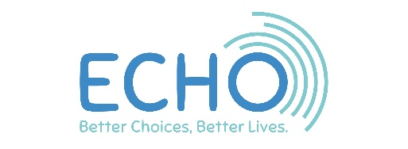
ECHO is a charity.

There are lots of rules about being a charity that we have to follow to make sure that we do a good job, treat everyone well and follow the law.

ECHO also sells things so we need to make sure that we follow the laws and rules for a business as well.

To do that, ECHO has to have something called a Memorandum and Articles of Association.
What is a Memorandum and Articles of Association? It is a legal document that says how ECHO is run, organised and owned.

The Memorandum says that
• ECHO is a registered company with the
government

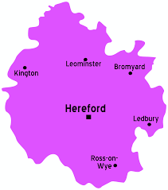
• ECHO is based in Herefordshire

• ECHO works with adults with learning disabilities, physical disabilities and mental health difficulties who we call participants

• ECHO offers activities for educational, training and sports, social and leisure. It also offers volunteering opportunities

The Memorandum says that ECHO is allowed to
- Be a charity as well as a business

- Have a bank account to pay money in and out.
It can save money and invest it for the future

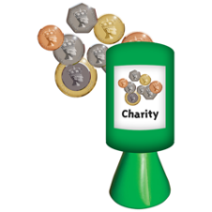
- Raise money, but it can only be spent on
things that will help our participants

- Rent or buy and sell property

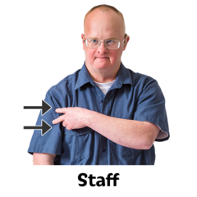
- Employ staff and also have a board of
directors who cannot be members of staff. We
call the directors our Trustees

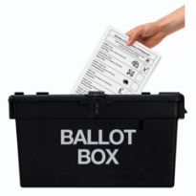
- ECHO can have shareholders or members and
they get to vote on things to do with ECHO

- ECHO can work with other charities and
local authorities including Herefordshire
Council

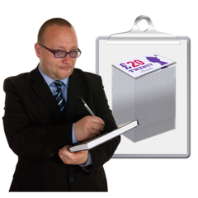
- ECHO must have insurance to protect us
if anything bad happens.

- If ECHO ever closed, it would pay any
money it owed to people and then if there was
any left, give it to another charity

The Articles say what the Board of Directors who we call Trustees must do to follow these rules of the Memorandum and Articles of Association.

- Every Year ECHO must have an annual review of its financial accounts and write an annual report to give to ECHO members

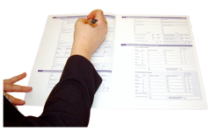
- Every Year ECHO must write a report for Companies House and the Charities Commission.

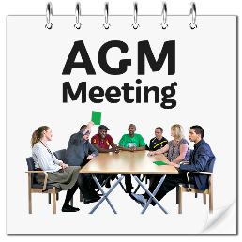
- Every year ECHO must hold an annual general meeting (AGM) and tell people the date of the AGM at least 21 days before it happens

The AGM
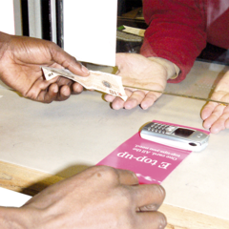
- Every member of ECHO can come to the AGM and vote. To be a member of ECHO you have to pay a small fee

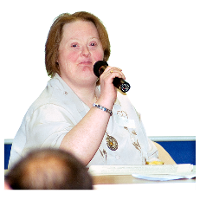
- The AGM must have a Trustee there to run the meeting. We call them the Chair

- Someone has to write down what was said at the meeting. We call that taking minutes

- At least 20 members have to be at the AGM for it to be legal

- Members can vote by raising their hand or by filling in a form and sending it in the post. If there are an equal number of votes, the Chair will make the decision and get the final vote

- Trustees can call extra meetings if something important happens that we all need to talk about

- The Memorandum and Articles can only be changed or have things added or removed if it is voted on by ECHO members at the AGM

ECHO Trustees
- ECHO should have at least 3 Trustees but aim to have 15 Trustees

- Some of our Trustees are participants who have disabilities

- You cannot be a Trustee if you are under 18, or if you are not allowed to because you have been disqualified by law from holding the post, or if you become too unwell to do the job or you resign

- Trustees do not get paid to be a Trustee but they can claim a small amount of expenses

- Trustees must be voted for and approved by members at the AGM

- 3 Trustees step down and retire at every AGM. ECHO members then vote for new Trustees to replace them

- Trustees can decide they want to keep being Trustees and ask to be voted back on as a Trustee

- Trustees cannot change the way the charity works without getting approval from ECHO members first at the AGM

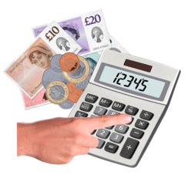
- Trustees can spend and invest money and sign contracts for ECHO

ECHO Trustees must
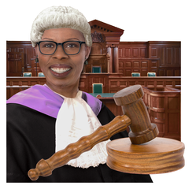

- Agree to have a legal responsibility for ECHO

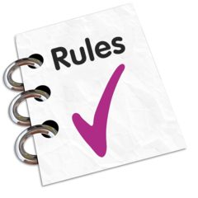
- Follow the rules of ECHO, Companies House, the Charity Commission and the law.

- Agree to act in ECHO’s best interests and can not change the way the charity works without getting approval from ECHO members first
- Put the interests of ECHO first and not try to do anything that will only benefit themselves or others
- Let ECHO know if they have a conflict of interests. They might not be able to vote on something if the decision might benefit them, their friends and family or other people or organisations they work with

- Meet up to discuss important things and make decisions about ECHO. They ask one Trustee to lead or Chair the main meeting. There can also be other smaller Trustee groups that meet to discuss things about ECHO

If you are happy for ECHO to follow these rules of the Memorandum and Articles of Association, please vote yes on the 2021 AGM voting form. If you have any questions or would like some help to read this, please call Claire on 01568 620307

