Dear ECHO members, Staff, Volunteers, Family and Friends
The ECHO trustees would like to invite you to the
ECHO Zoom AGM on
Friday 10th December 2021 at 2pm.

The AGM will be on Zoom this year.
The Theme for the AGM this year is Christmas. We hope that you will wear fun jumpers, dress up as decorations, or animals or anything else to do with Christmas that you like.
We will also have a signing song and this year it will be What a Wonderful world by Louis Armstrong.
If you would like to come to the Zoom ECHO AGM, please fill in the form below and send it to the office by post or email or hand in at your projects so they can send it to the office. It is important that you give us the email address you want the Zoom link to be sent to. If you attend an ECHO project on a Friday, you do not need to book a place.
If there is no way for you to join us on Zoom, will have a limited number of places at venues in Leominster and Hereford for you to watch the zoom AGM. We are not able to have a party this year and there will be no refreshments at the venues.
If you want to come to one of the ECHO venues, you will need to book a place, so please return your form by 8th November so we can send you a free ticket. We need to make sure we can be Covid safe so it is very important that you book a place.
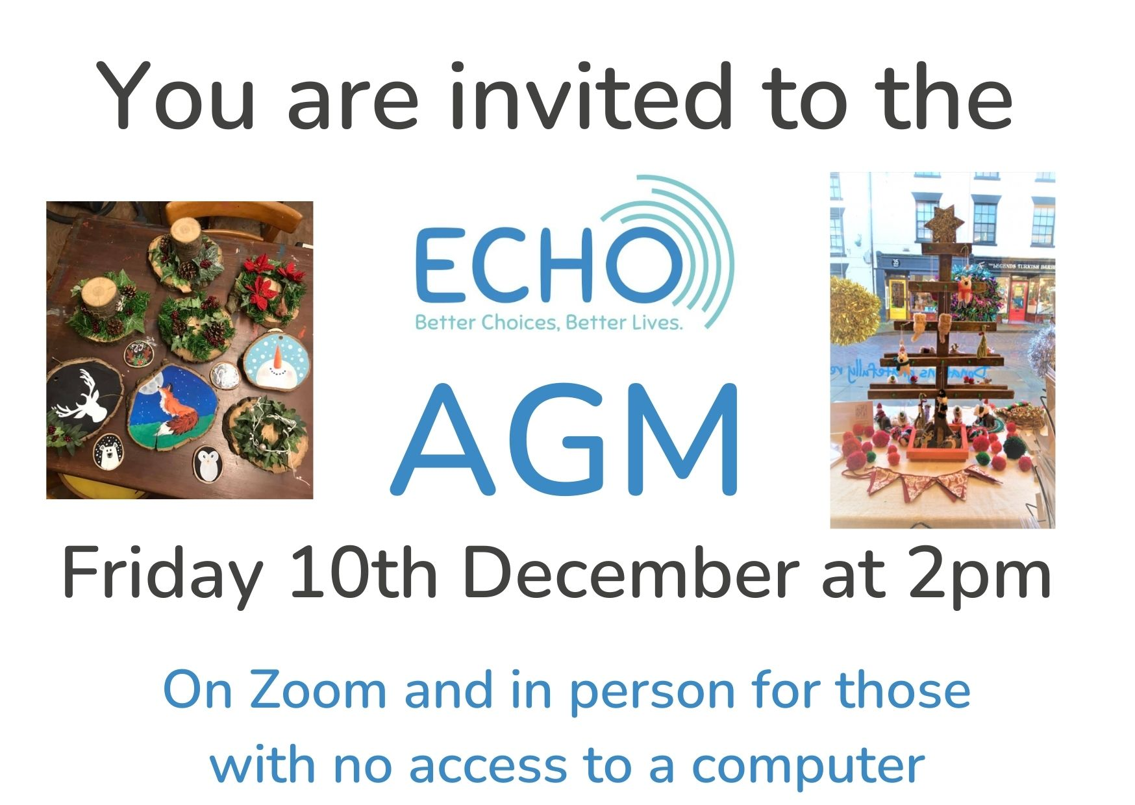

AGM Booking Form
Friday 10th December at 2pm

Name: ……………………………………
Phone number: …………………………………………..

Yes, I want to come to the ECHO Zoom AGM on 10th December
Please send the zoom link to this email address

Email: ……………………………………………………………………………………………..
or
Yes, I want to come the AGM but I do not have a computer or tablet and cannot get onto Zoom

Please can I come to the Leominster venue
Please can I come to the Hereford venue

I need to book 1 place
I need to book 2 places – one for me and one for my support

