ECHO Christmas Card Competition 2020
Every year the Rep Group send a letter to all ECHO staff and volunteers to thank them for the support they have given ECHO participants over the past year. We know how hard our staff and volunteers work for us and we feel it is important to say thank you.
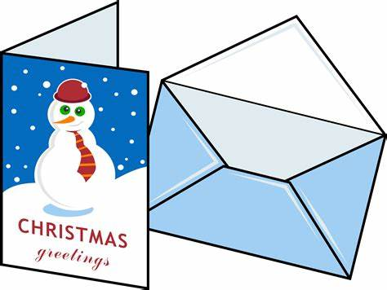
Last year we had a Christmas Card Competition for participants, and we are using the winning designs for this year’s cards. There were some brilliant entries, so we have decided to do this again this year. If you are an ECHO participant and would like to enter please read and follow the instructions below and fill in the entry form on the other side of this paper. There will be 1 prize of £15 for the winning design, plus a pack of your own cards.
Please read these instructions before you do your design.
- It must be a Christmas picture
Think about your design, try and make it interesting & special.
- It must be a flat picture. Do not use glitter or stick things on.

- You must have drawn or painted it yourself.
A4
- It must be on clean, white A4 paper,
and be in the Portrait position

ECHO Christmas Card Competition 2020

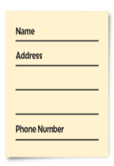
If you want to enter the competition please fill in this form and and send it back to ECHO with your picture.

Name:

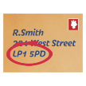
Address:

Postcode

Phone number:

Email Address:

When you have done your design make sure it stays flat and clean, and send it with this form to ECHO by

Thursday 28th January 2021.

You can:
- Give it to your activity leader
- Post it or bring it into us at:
ECHO, 40 West Street, Leominster, HR5 8ES.

To send us your picture and this form

Thank you

