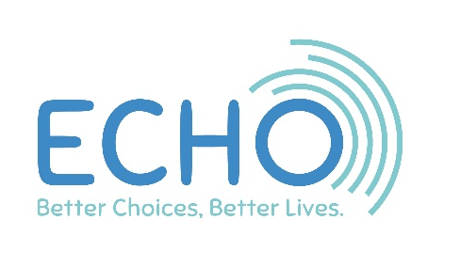

Money

This is a summary of how we have spent our money this year. Full copies of our accounts are available from the ECHO Office and on our website.

Summary Income & expenditure for the year ending 31/3/20

 | 2019 | 2020
INCOME FROM:
Generated funds | £99,587 | £114,732
Charitable activities | £668,569 | £643,871
Total income | £768,156 | £758,603
MONEY SPENT ON:
Fundraising costs | £16,332 | £20,959
Charitable activities | £741,798 | £790,077
TOTAL MONEY SPENT | £758,130 | £811,036
Balance | £10,026 | -£52,433
Money brought forward | £331,645 | £341,671
Money to carry forward | £341,671 | £289,238
Balance Sheet for Year ending 31/3/19

 | 2019 | 2020
Current Assets | £388,530 | £314,525
Creditors | £(46,859) | £(30,086)
Net Current Assets | £341,671 | £284,439
FUNDS
Restricted | £49,368 | £29,695
Unrestricted General | £189,021 | £240,320
Unrestricted Designated | £103,282 | £19,223
TOTAL FUNDS | £341,671 | £289,238

