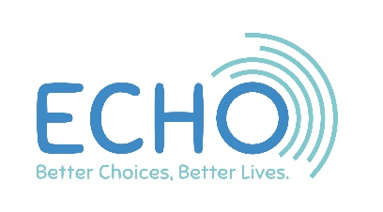
October 2020

Dear ECHO member
We could not have our Annual General Meeting, the AGM, in September due to Covid-19.
We still cannot have a large group of people together so we are pleased to tell you that we will be holding an online AGM this year. It will be on Thursday 3rd December starting at 10.30am.
Although this will be very different, we still hope to have fun! We would like everyone to wear a hat, any hat. Make one, borrow one find it at the back of your wardrobe! Also make a small hand-held flag to wave. We will also be doing the signalong song ‘tightrope’ a video of the signs can be found on YouTube if you want to practice.
The trustees need ECHO members to vote for some things at the AGM.
It would be hard to count our members votes at an online meeting, so we need you to vote before the meeting. When you have voted please send your voting forms back to us. With this letter you will find:
- AGM invitation and booking form
- the minutes from last year’s AGM
- A summary of ECHO’s accounts
- your voting forms for the meeting
- your voting forms to agree our new trustees
The full trustees report and annual accounts can be found on the ECHO website on the ‘Our Structure and who runs ECHO page’.
We hope to see you at our online meeting.

Kind regards
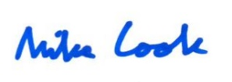
Mike Cook
Chief Officer

